  - DEMAND MO

Customer Onboarding System (COS)
  - A repeatable operating system for activating new Demand Mo users and teams.
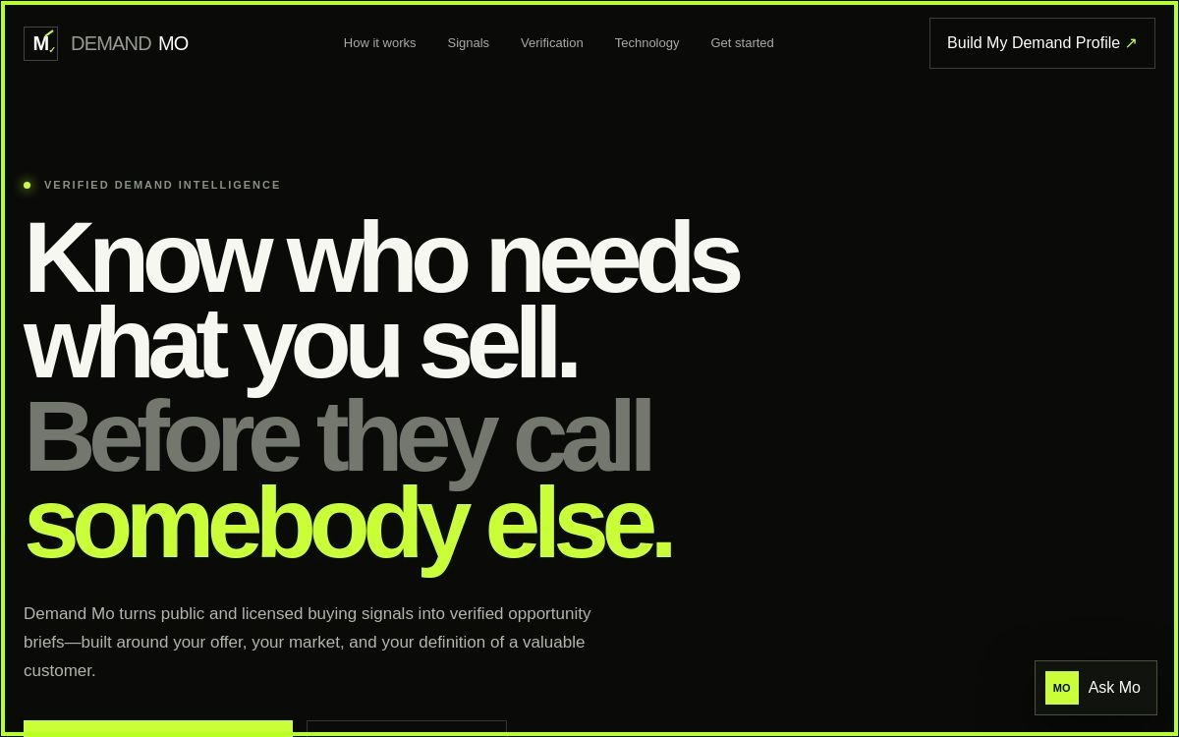
Production guide • Version 1.0 • 17 August 2026

Purpose and graduation standard
The COS moves a user from orientation to a repeatable weekly demand-intelligence workflow. A user graduates when they can create a Demand Profile, interpret evidence, use Ask Mo, explain why an opportunity matters now, and document a responsible next action.
Audience | Primary job | Graduation evidence
New user | Find and understand qualified demand | Saved profile + one evidence-led opportunity brief
Sales / BD | Prioritize outreach | A researched account and defensible next step
Manager | Set standards and coach usage | Quality review and weekly operating cadence
Administrator | Control access, policy, and integrations | Approved sources, roles, retention, and command scope

Learning outcomes
- Describe what Demand Mo does—and what it does not do.
- Build a Demand Profile using offer, market, buyer, geography, and signal criteria.
- Separate raw signals from verified evidence and clearly label uncertainty.
- Use Ask Mo for product guidance without assuming it is a general-purpose autonomous agent.
- Apply the seven-question Opportunity Reasoning Engine consistently.
- Operate within privacy, licensing, source-terms, and human-approval requirements.

Onboarding journey
Stage | Timing | Owner | Activity | Pass condition
0. Prepare | Before Day 1 | Admin | Approve audience, data sources, roles, command permissions | Workspace and policy ready
1. Orient | Day 1 · 15 min | Champion | Tour value proposition, navigation, Ask Mo | User can locate every primary control
2. Profile | Day 1 · 20 min | User | Create first Demand Profile | Reference ID recorded
3. Evidence | Day 2 · 30 min | Coach | Review source, recency, corroboration, confidence | User explains evidence chain
4. Reason | Day 2 · 30 min | User | Answer seven opportunity questions | Brief is complete and traceable
5. Act | Day 3 | User + manager | Choose a proportionate human-approved next step | Action and owner assigned
6. Embed | Days 4–7 | Manager | Run first weekly review | Cadence, metrics, and escalation path agreed

Module 1 — Product orientation
Outcome: distinguish a verified opportunity brief from a lead list. Exercise: explain the homepage promise in your own words and identify the profile and guide controls.

Module 2 — Demand Profile
Outcome: define a narrow, testable search thesis. Exercise: enter one offer, buyer problem, market, geography, signal type, and exclusion; submit and retain the DM reference.

Module 3 — Signals and verification
Outcome: assess evidence quality. Use a four-part check: source legitimacy, direct relevance, recency, and independent corroboration.

Module 4 — Ask Mo
Outcome: obtain product help. Ask one navigation question, one profile question, and one verification question; confirm that responses describe a next step rather than silently executing external actions.

Module 5 — Opportunity reasoning
Outcome: produce a brief answering: company; problem; evidence; cost; decision owner; solution; why now.

Module 6 — Responsible action
Outcome: choose outreach or investigation proportional to confidence. Never infer sensitive traits, bypass access controls, or contact people automatically without approved policy.

Module 7 — Team operating rhythm
Outcome: run a weekly 30-minute review: new profiles, evidence quality, qualified briefs, next actions, false positives, source issues, and feedback.

Facilitator runbook
Minute | Facilitator action | Participant action
0–5 | Set outcome and boundaries | State use case
5–15 | Demonstrate navigation | Follow along
15–30 | Coach profile creation | Submit profile
30–45 | Teach evidence rubric | Score an example
45–60 | Guide seven-question brief | Complete brief
60–70 | Review Ask Mo | Ask two questions
70–80 | Agree next action and cadence | Commit owner/date

Quality rubric
Dimension | Ready | Needs work
Profile | Specific offer, problem, market, and signals | Broad market or missing exclusions
Evidence | Traceable, current, corroborated | Single weak or ambiguous signal
Reasoning | All seven questions answered | Claims outrun evidence
Action | Named owner, date, human approval | Automated or undefined outreach
Governance | Approved sources and retention | Unknown license, terms, or privacy basis

30-day success measures
- Activation: profile submitted and Ask Mo used during first session.
- Time to first qualified brief.
- Percentage of briefs with traceable evidence and all seven questions complete.
- False-positive rate and reasons.
- Weekly active users and completed review cadence.
- Zero unauthorized source, privacy, or remote-command incidents.

Administrator production checklist
- Confirm public pages contain no demo claims, fabricated customers, or fake live metrics.
- Audit every repository, dependency, model, data source, and deployment artifact for license and source terms.
- Restrict SSS Brain remote commands to an authenticated allowlist; log requester, command, result, and timestamp; require human approval for consequential actions.
- Configure secrets outside source control; rotate keys; apply least privilege; test backup and recovery.
- Set privacy notice, retention, deletion, incident response, accessibility, monitoring, and support ownership.
- Run acceptance tests for profile submission, Ask Mo, mobile layout, keyboard use, download links, API health, and failure states.

Open-source implementation map
Capability | Preferred V1 | Controlled / optional
Crawling | Crawl4AI, Scrapy | Playwright when rendering is required
Recon | SpiderFoot, HTTPX | WAFW00F with authorization
Browser assistance | Playwright | Nanobrowser after security review
Local AI | Ollama | Model license and hardware review
Identity discovery | — | Maigret / Sherlock only for lawful approved use
Storage | PostgreSQL + pgvector | Qdrant if operational need justifies it
Repository licenses above are top-level indicators, not legal clearance. Complete dependency, model, content, privacy, and terms-of-service reviews before production use.

Support and escalation
Product question → Ask Mo. Data or evidence concern → team reviewer. Access or integration concern → administrator. Suspected privacy/security incident → stop the workflow, preserve logs, and follow the organization’s incident-response process.

