  - DEMAND MO

Training Video Script & Storyboard
  - A production-ready, approximately 10-minute walkthrough for new Demand Mo users.
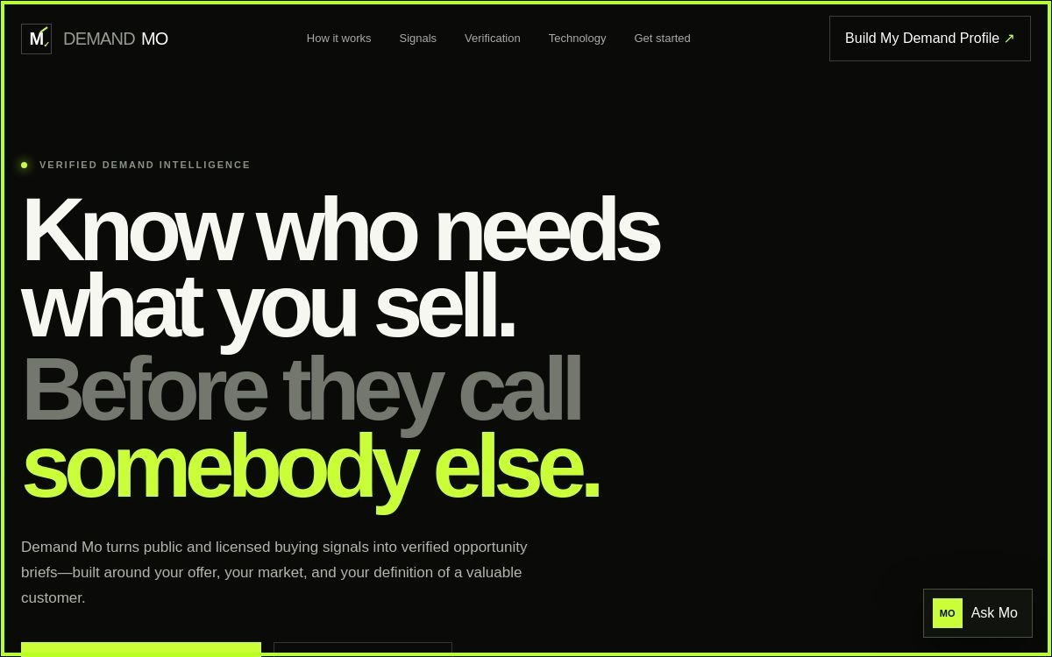
Production guide • Version 1.0 • 17 August 2026

Production brief
Item | Direction
Audience | First-time users, sales/BD teams, managers
Runtime | 9–11 minutes
Format | 16:9, 1080p, cursor highlight, captions on
Voice | Calm, precise, evidence-led
Visual style | Black, warm white, lime accent; match live product
Privacy | Use fictional company data; blur email and DM references
Deliverables | Master, captioned version, SRT/VTT, thumbnail, chapter markers

Before recording
- Use the current production site and a clean supported browser.
- Prepare fictional profile text that contains no customer or personal data.
- Set browser zoom to 100%, notifications off, and cursor emphasis on.
- Confirm profile submission and Ask Mo in a non-destructive production test.
- Capture a fallback still for each scene.

Storyboard and narration

Scene 1 · 0:00–0:25
Screen action | On-screen direction
Full homepage; slow push toward headline. | Title: Know who needs what you sell.
NARRATION Demand Mo turns public and licensed buying signals into verified opportunity briefs built around your offer, market, and definition of a valuable customer.

Scene 2 · 0:25–1:05
Screen action | On-screen direction
Move across top navigation; pause on each label. | Highlight each button as named.
NARRATION Start with the product map. How it works explains the workflow. Signals shows what may indicate demand. Verification explains the evidence standard. Technology describes the self-hosted architecture. Get started takes you to profile creation.

Scene 3 · 1:05–2:50
Screen action | On-screen direction
Select Build My Demand Profile; complete fictional fields. | Callout: Never enter passwords or private keys.
NARRATION Select Build My Demand Profile. Define a narrow thesis: what you offer, the problem it solves, the market and geography, the signals that matter, and anything that should be excluded. Specific inputs produce more defensible research.

Scene 4 · 2:50–3:25
Screen action | On-screen direction
Select Create My Profile; zoom on confirmation. | Blur email and most of reference.
NARRATION When the profile is complete, select Create My Profile once. A confirmation and DM reference mean the backend accepted your profile. Save that reference for support and review.

Scene 5 · 3:25–4:30
Screen action | On-screen direction
Scroll to Signals and Verification. | Four checks appear one at a time.
NARRATION A signal is an invitation to investigate, not proof of intent. Check source legitimacy, direct relevance, recency, and independent corroboration. Keep assumptions labeled.

Scene 6 · 4:30–6:05
Screen action | On-screen direction
Open Ask Mo; submit two example questions. | Examples: “How do I improve my profile?” “How is evidence verified?”
NARRATION Ask Mo is the in-product guide. Open it from the lower-right corner, enter one concise question, then select the send arrow or press Enter. Ask about navigation, profile design, evidence, technology, or privacy. Treat the response as guidance unless the interface explicitly confirms an approved action.

Scene 7 · 6:05–7:25
Screen action | On-screen direction
Show seven-question graphic or brief checklist. | Display numbered seven-question list.
NARRATION Every opportunity brief should answer seven questions: who is the company, what problem exists, what proves it, what the problem costs, who owns the decision, how your solution helps, and why action matters now. If evidence is weak, the correct result is more research—not stronger language.

Scene 8 · 7:25–8:15
Screen action | On-screen direction
Scroll to Technology section. | Show core stack, then “controlled add-ons”.
NARRATION Demand Mo is designed around self-hosted open-source components for crawling, browser automation, reconnaissance, local AI, and vector search. Top-level licenses are only a starting point; dependencies, model terms, data-source rules, and privacy obligations still require review.

Scene 9 · 8:15–9:05
Screen action | On-screen direction
Show SSS Brain architecture slide. | Diagram: SSS Brain → authenticated gateway → Demand Mo → signed result.
NARRATION The planned SSS Brain connection uses an authenticated command gateway. Commands should be allowlisted, schema-validated, logged, and subject to human approval when consequential. Documentation of the connection is not the same as granting remote access.

Scene 10 · 9:05–9:50
Screen action | On-screen direction
Return to profile and Ask Mo controls. | Checklist animates.
NARRATION Your weekly rhythm is simple: refine the profile, review new signals, verify the evidence, complete the seven-question brief, choose a proportionate human-approved next step, and record feedback.

Scene 11 · 9:50–10:10
Screen action | On-screen direction
End card with site and support route. | End card: demandmo.biz • Build. Verify. Act responsibly.
NARRATION You are ready to build your first Demand Profile. Visit demandmo.biz, and use Ask Mo whenever you need product guidance.

Editor notes
- Cut on cursor arrival, not mid-motion. Allow at least two seconds after each click so viewers can see the state change.
- Use 125–150% crop-ins for small controls; retain context before zooming.
- Caption all narration and meaningful interface text. Maintain high contrast and avoid lime body text on white.
- Add a short success tone only after confirmed profile submission; use no sound that suggests execution when Ask Mo merely gives guidance.
- If the UI differs at recording time, update the narration and callouts to match the live interface before publishing.

Training assessment
After watching, ask the learner to: identify the two primary controls; create a fictional profile; explain the difference between a signal and evidence; name the seven brief questions; and state one SSS Brain command safeguard. Passing score: all five tasks completed without entering sensitive data.

