  - DEMAND MO

User Guide
  - Step-by-step instructions for the public production experience at demandmo.biz.
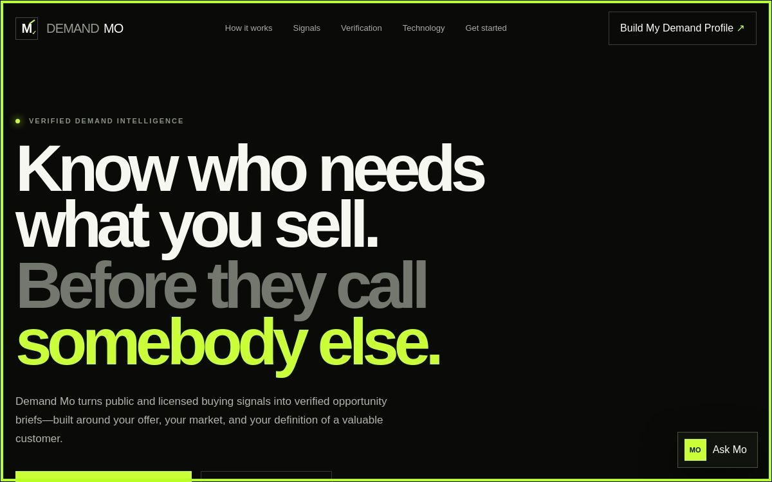
Production guide • Version 1.0 • 17 August 2026

Quick start
- Open demandmo.biz.
- Select Build My Demand Profile.
- Complete every required field with a specific, testable demand thesis.
- Select Create My Profile.
- Record the DM reference shown after submission.
- Use Ask Mo for navigation, profile, evidence, technology, or privacy guidance.

1. Understand the home screen
Screenshot 1 — Production navigation and primary profile action.
Control | What happens | Expected result
DEMAND MO logo | Returns to the top of the page | Hero section is visible
How it works | Moves to the process section | Process explanation is in view
Signals | Moves to signal categories | Signal types are in view
Verification | Moves to verification method | Evidence standards are in view
Technology | Moves to the architecture section | Core and controlled open-source components are shown
Get started | Moves to the onboarding call to action | Profile action is visible
Build My Demand Profile | Opens the profile dialog | Form appears over the page
Ask Mo | Opens the guide panel | Prompt field and guide response area appear

2. Create a Demand Profile
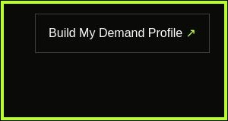
Screenshot 2 — Primary profile button.
- Select Build My Demand Profile.
- Read each label before entering data. Describe the offer and customer problem concretely; avoid “all businesses.”
- Specify market, geography, signal criteria, and exclusions so results can be evaluated.
- Provide a valid contact email if requested for the saved profile workflow.
- Select Create My Profile once. Wait for the confirmation state.
- Copy the generated DM reference. It is the durable confirmation that the backend accepted the profile.
If this happens | Meaning | What to do
Confirmation + DM reference | Profile saved successfully | Store the reference and proceed to review
Inline validation | A required or formatted field is incomplete | Correct the highlighted value and resubmit
Network/server error | The request was not saved | Keep your text, wait briefly, retry once, then escalate with time and browser
Repeated click appears inactive | Request may already be processing | Do not create duplicates; wait for confirmation

3. Use Ask Mo
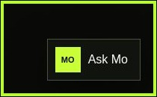
Screenshot 3 — Ask Mo launcher in the lower-right corner.
- Select Ask Mo.
- Type one concise question in the prompt field.
- Select the send-arrow button or press Enter.
- Read the answer and use the suggested next step.
- Ask a narrower follow-up if the response is too general.
Try asking | Expected guidance
How do I create a profile? | The steps and fields used to submit a Demand Profile
What counts as a signal? | Examples and the difference between a signal and proof
How is evidence verified? | Source, relevance, recency, and corroboration checks
What technology powers this? | The self-hosted open-source architecture and controlled add-ons
How does SSS Brain connect? | Authenticated command-gateway concept, audit logging, and permission boundaries
Ask Mo is a product guide. Treat it as instructional unless the interface explicitly confirms that an approved command was executed. Never paste passwords, access tokens, private keys, or sensitive personal data into prompts.

4. Read an opportunity brief
Question | A complete answer contains
Who is the company? | Identity, market, and relevant operating context
What problem exists? | A specific, observable business problem
What is the evidence? | Traceable sources, dates, and corroboration
What is the cost? | Operational, financial, risk, or time impact—with assumptions labeled
Who owns the decision? | Likely accountable role, not an unverified personal claim
How does the solution help? | Clear fit between need and capability
Why now? | A time-bound trigger that changes urgency

5. Evidence rules
- A signal starts an investigation; it does not prove intent.
- Prefer direct and current sources. Record the URL/source, date, relevant excerpt or fact, and confidence.
- Corroborate meaningful claims using an independent source when practical.
- Label inferred cost, ownership, and urgency as hypotheses until verified.
- Respect robots rules, access controls, licenses, source terms, privacy law, and organizational policy.

6. SSS Brain and remote commands
The intended connection is GitHub repository github.com/swadesoul/sssbrain, associated with sssbrain.lovable.app and sssbrain.live. A production connection should send authenticated, schema-validated commands to Demand Mo; authorize only allowed operations; require human approval for consequential actions; return a signed result; and retain an audit record. Website text documenting this architecture does not itself grant remote control.

7. Mobile, keyboard, and accessibility
- Use browser zoom without losing access to controls.
- Tab through navigation, profile fields, dialog close control, and Ask Mo; a visible focus indicator should follow.
- On a small screen, scroll within the dialog if necessary before submitting.
- Use explicit field labels and error text; do not rely on color alone.

8. Troubleshooting
Problem | Resolution
Page does not load | Check connection; retry demandmo.biz; record timestamp and browser
Section link misses target | Scroll manually; refresh and retry once
Profile dialog will not open | Allow page scripts; refresh; try a supported current browser
Profile will not save | Resolve validation, confirm connection, retry once; do not include secrets in support evidence
Ask Mo gives no answer | Shorten the question, retry, then report exact prompt and time
Download does not start | Open link in a new tab or use browser Save Link As

9. Safe-use checklist
- I used only approved public or licensed data.
- I can trace important claims to evidence.
- I labeled assumptions.
- I did not add secrets or unnecessary personal data.
- A human reviewed consequential outreach or remote action.
- I recorded the profile or command reference.

